1. INTRODUCTION

1.1 PURPOSE

The purpose of this document is to build an online system to manage pet products and customers to ease the pet shop management.

1.2 DOCUMENT CONVENTIONS

This document uses the following conventions:

DB: Database

ER: Entity Relationship

1.3 INTENDED AUDIENCE AND READING SUGGESTIONS

This project is useful for the pet shop management team and customers looking to purchase pet products online.

1.4 PROJECT SCOPE

The purpose of the online pet shop system is to ease pet product management and create a convenient and easy-to-use application for customers. The system is based on a relational database with its product management and shopping functions. We aim to provide a comfortable user experience along with the best pricing available.

2. OVERALL DESCRIPTION

2.1 PRODUCT PERSPECTIVE

A pet shop database system stores the following information:

Product details: Includes product name, description, price, and stock quantity.

Customer details: Includes customer name, address, and contact information.

Order details: Includes order date, total amount, and products ordered.

2.2 PRODUCT FEATURES

The major features of the pet shop database system include:

Browsing products by category

Searching for products

User registration and login

Shopping cart management

Checkout and payment processing

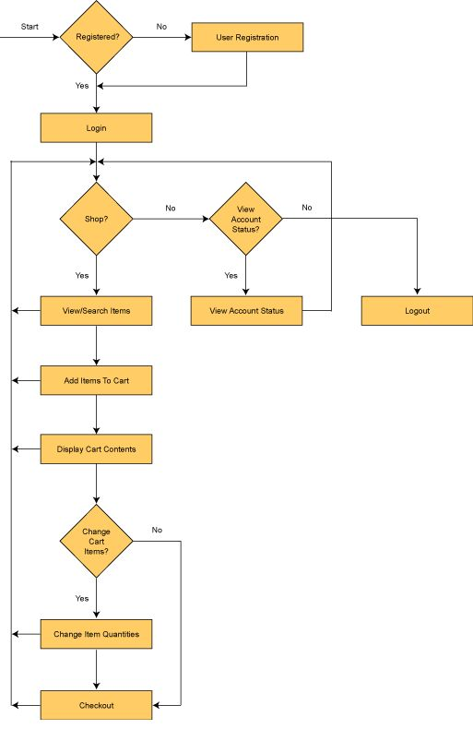

2.3 USER CLASS AND CHARACTERISTICS

Users of the system include:

Customers: Can browse products, make purchases, and manage their accounts.

Admin: Can manage products, view orders, and handle customer queries.

2.4 OPERATING ENVIRONMENT

The operating environment for the pet shop management system includes:

Operating system: Windows, Linux, macOS

Database: SQL-based database

Platform: Web-based application

2.5 DESIGN AND IMPLEMENTATION CONSTRAINTS

The system must ensure secure transactions and data protection.

The website should be responsive and accessible on various devices.

2.6 ASSUMPTION DEPENDENCIES

The system assumes a stable internet connection for users.

The system relies on third-party payment gateways for transaction processing.

3. SYSTEM FEATURES

DESCRIPTION AND PRIORITY

The pet shop system maintains information on products, customer preferences, prices, and orders. This project has a high priority to ensure smooth online shopping for customers.

STIMULUS/RESPONSE SEQUENCES

Search for Products: Displays a list of available products based on search criteria.

Make a Purchase: Allows customers to add products to the cart and complete the purchase.

Cancel an Order: Customers can cancel their orders before shipment.

**FUNCTIONAL REQUIREMENTS**

* Product Management: Admin can add, update, or delete products.
* User Management: Customers can register, log in, and manage their profiles.
* Order Management: Customers can place orders, view order history, and track shipments.

4. EXTERNAL INTERFACE REQUIREMENTS

4.1 USER INTERFACES

The website should have a user-friendly interface with intuitive navigation.

4.2 HARDWARE INTERFACES

Compatible with standard web browsers on desktops and mobile devices.

4.3 SOFTWARE INTERFACES

Integrates with third-party payment gateways.

4.4 COMMUNICATION INTERFACES

Supports email notifications for order confirmations and updates.

5. NONFUNCTIONAL REQUIREMENTS

5.1 PERFORMANCE REQUIREMENTS

The website should load within 3 seconds.

The system should handle up to 10,000 concurrent users.